Summer Internship Project Report

On

Real Time Face Recognition and Tracking

|  |
| --- |
| **lo.PNG** |
| **LeadingIndia.ai** |

|  |  |
| --- | --- |
| **Submitted To:**  Mr. Tejalal Choudhary  Ph.D. Scholar,  Bennett University | **Submitted By:**  Team Number – **19**  1.Jithu Divakaran  2.Yash Tibarewala |
| Department of Computer Science Engineering  School of Engineering and Applied Sciences  Bennett University  Greater Noida  Uttar Pradesh |  |
|  |  |

**Abstract**

The rapid advancements in the field of **computer vision**, which is backed by the powerful **Deep Learning algorithms** made it easy to Recognize and Identify a person based his unique facial characteristics. In a real streaming environment this concept has great importance.

This project aims at automatically calculating the time duration that a person spend in a room through recognition and re-identification of person’s face in a completely automated manner by using dedicated cameras fixed in the room entrances and exits.

Tracking of visitors in manually is time consuming and difficult task. It requires more human intervention and time. But this project offers a complete and accurate automatic visitor tracking mechanism through deep learning.

This project can mainly consider as a way of security measure. But its scope can be extended to several other areas also.

**Acknowledgement**

On the submission of our project report on “**Real Time Face Recognition and Tracking**”, we would like to extend our gratitude and sincere thanks to our Mentor Mr.Tejalal Choudhary, Ph.D. Scholar, Department of Computer Science Engineering Bennett University for his constant motivation and support during the course of our work in the last one Month. We truly appreciate and value his esteemed guidance and encouragement from the beginning to the end of this Project. We are indebted to him for having helped us shape the problem and providing insights towards the solution. We want to thank all our teachers Dr. Gaurav Singal, Assistant Professor, Bennett University and Dr. Madhushi Verma Assistant Professor, Bennett University for providing a solid background for out studies and research thereafter. They have been great sources of inspiration to us and we thank them from the bottom of our heart. Above all, we would like to thank all our friends and other group members whose direct and indirect support helped us complete our project in time. The Project would have been impossible without their perpetual moral support.

**INDEX PAGE NO:**

**Abstract**.........................................................................................................*01*

**Acknowledgement**........................................................................................*02*

**1. Introduction**

1.1 Problem Statement….....................................................................*04*

1.2 Overview.......................................................................................*04*

1.3 Objective/Motivation....................................................................*05*

1.4 Relevance of the project…………………………………….. ….*05*

**2. Real Time Face Recognition and Tracking**

2.1 Introduction to problem….............................................................*06*

2.2 Dataset Collection …………………………………………….....*08*

2.3 Implementation details-Snapshots.................................................*10*

* 1. Libraries, Classifiers and Platform................................................*11*

2.5Project Development Time Schedule ……………………………*11*

2.6 Project Screenshots……………………………………………....*12*

**3. Conclusion, Limitations & Future Scope**

3.1 Conclusion......................................................................................*13*

3.2 Limitations……………………………………………………......*13*

3.3 Future Scope....................................................................................*13*

**Links..........................................................................................................*14***

**References.................................................................................................*14***

**1. Introduction**

The face is one of the easiest ways to distinguish the individual identity of each other.Face Recognition (FR) is becoming a new trend in the security authentication systems. Modern FR systems can even detect, if the person is real (live) or not while doing face recognition. Face Recognition software has become very powerful, user-friendly and less and less expensive. In **F**ace **R**ecognition the unique features in human faces are treating as the basic measures for facial comparisons. The **F**ace **R**ecognition System are introduced due to the advancements in the field of **computer vision**, which is backed by the powerful **Deep Learning algorithms**.

* 1. **Problem Statement:**

Manually monitoring a room or office becomes somewhat irrelevant today. The manual process of recording and calculating the entry and exit time ,tracing the visitors in a room has many limitations like limited accuracy, time consumption, resource requirements etc..The Real Time Face Recognition System is very efficient in identifying a person using his unique facial characteristics. This can be utilized to calculate the time that a person spends in a room. Now a days technique like Biometric and facial recognition are using for tracing a person’s presence or absence. But in this real time system, the device will automatically monitors the presence of individuals, and automatically mark their entry and exit time, so that the duration of time they have spend in a room can be easily and automatically calculated. This will increase the accuracy in computation and reduces the human effort in the processes.

* 1. **Overview**

The Steps Involved in the whole process are:

1. Identify, Capture, Crop and Align Face.
2. Generate Embeddings.
3. Compare Embeddings.
4. Calculate the time duration that he/she spend in the room.
   1. **Motivation**

The Face recognition has been a sought after problem of biometrics and it has a variety of applications in modern life. The problems of face recognition attract researchers working in biometrics, pattern-recognition field and computer vision. An efficient face recognition system can be of great help in forensic sciences, identification for law enforcement, surveillance, authentication for banking and security system, and giving preferential access to authorized users i.e. access control for secured areas etc. The problem of face recognition has gained even more importance after the recent increase in the terrorism related incidents.

So along with the capabilities of the Face Recognition Systems, the Real Time Tracking is implemented in this project. So that any person within the range can be properly recognize, monitor and track by the system. So the motivation behind this project is the wide range of possibilities in the fields of Computer Vision and Deep Neural Networks.

* 1. **Relevance of the project**

In the field of Security and Authentication the Face Recognition and Tracking has great role. Day by day the need for deep security is very high. The manual security system has its own limitations such as expensive, limited accuracy, extra recourse requirements etc.. Here comes the relevance of the Real Time Face Recognition And Tracking System. This project can be treated as a powerful, automated system for monitoring and tracking the visitors of room or office. It is a completely automated system that monitors and tracks the visitors in a real time manner. This can reduces the human efforts and possible issues of human oriented processes.

**2. Real Time Face Recognition And Tracking**

In a real time environment the project consists of two sections:

1. Face Recognition
2. Tracking

**Face Recognition**

In the real time environment the face recognition section involves capturing the face images of the visitor and to re-identify in an automated way. That means while detecting a human face, capture it and recognize it by comparing it with the previously collected data. This process can be illustrated as follows (fig:2.1 and fig:2 )

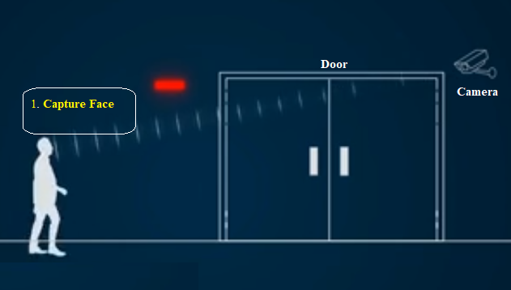

Fig: 2.1

Here whenever a human face is detected in the camera placed at the entrance, the face will be captured and labels it with the captured time. The timestamp can be used for the further time calculations.

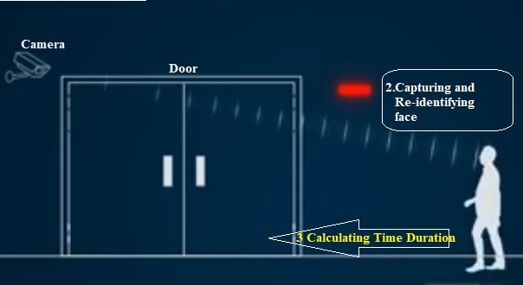

Fig: 2.2

In this case (Fig: 2.2) when the visitor is detected by the camera placed in the exit way, the face image will be captured by the camera and compares it with the previously captured images. If a true match is found then the time duration will be calculated by finding the difference of current time and time labelled on the matching image. If not report that person as an Unknown identity.

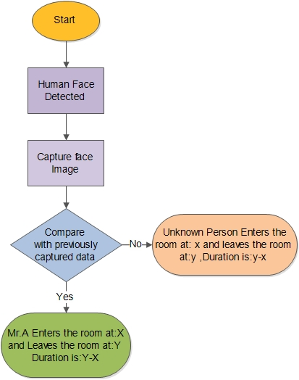The entire process can be represented as a Flow Chart as follows (Fig: 2.3):

**Fig: 2.3**

* 1. **Data Collection**

Data is the basic thing in any system. In our project we are using the images of different person to train the model. Different images of the same person in different angels, different light shades are stored in independent labelled directories. The directory structure is as follows: fig

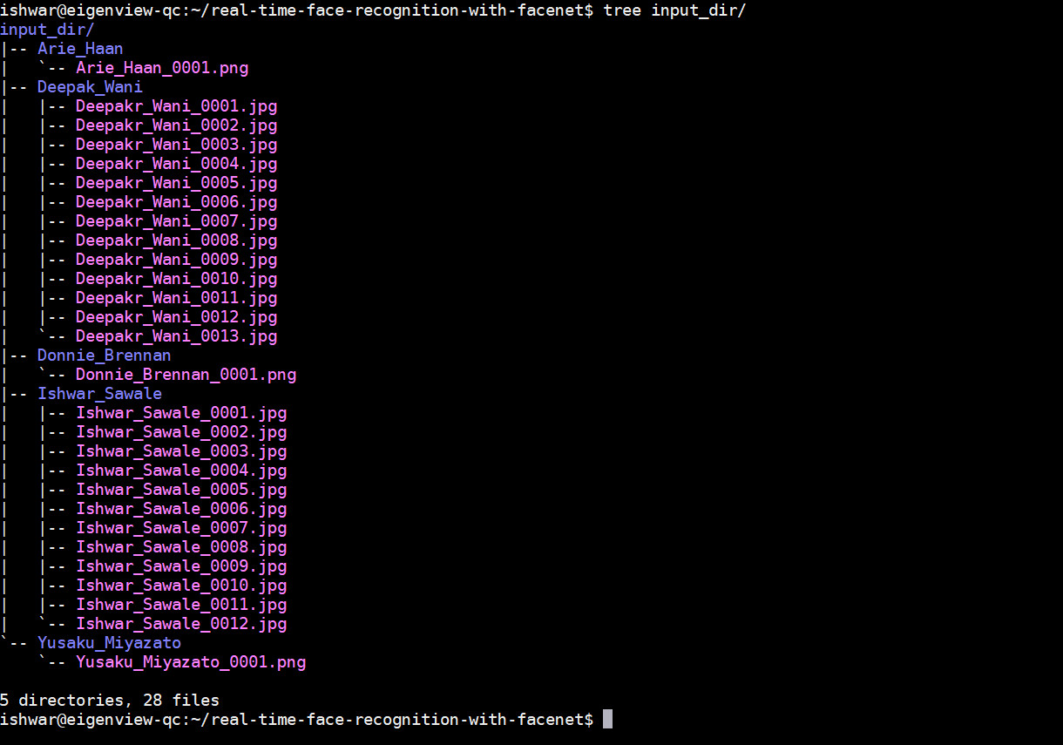

Fig: 2.4

Each of these directories contains more than 20 images of the respective persons. That means the directory labelled as Deepakr_Wani contains 20 different images of the person Mr. Deepakr_Wani and so on.

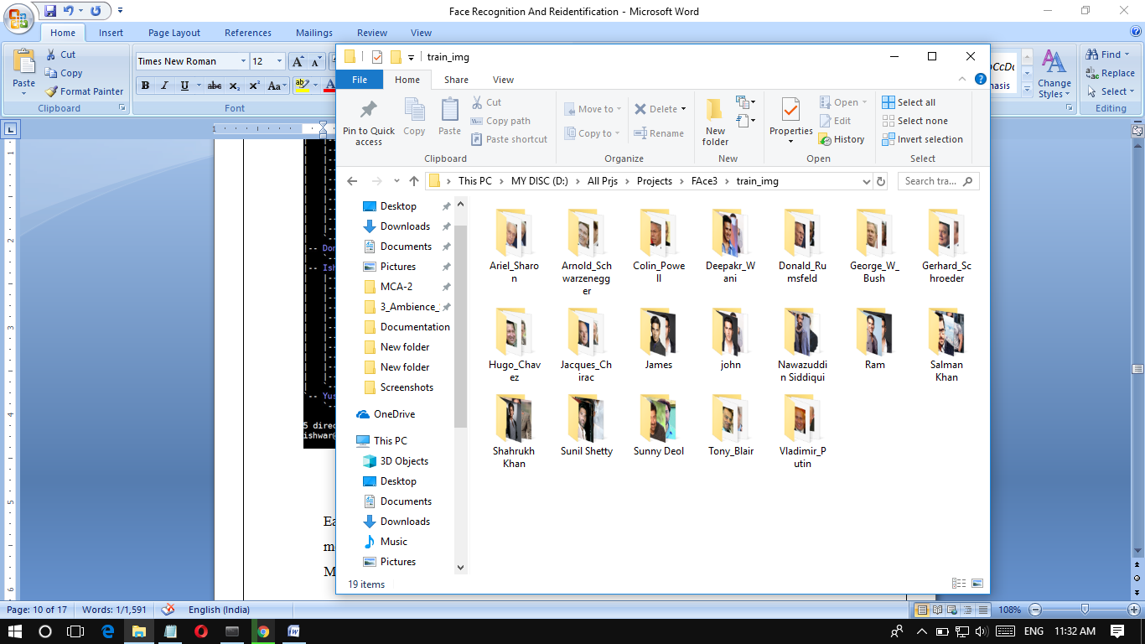

Fig: 2.5

* 1. **Implementation details**

**Phase 1** – Capturing the image of the person who entering into the room .And labels it with the Captured Time.

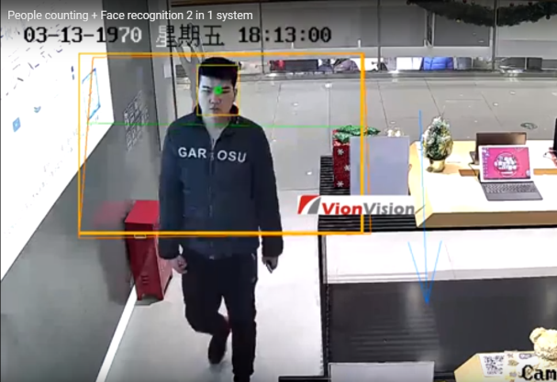

**Phase 2** - Aligning the facial part and labels it with the captured time.

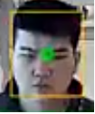

**Phase-3** The model generates the Embeddings for the respective Images.

**Phase 4** Capture the face while the person going out the room

1. 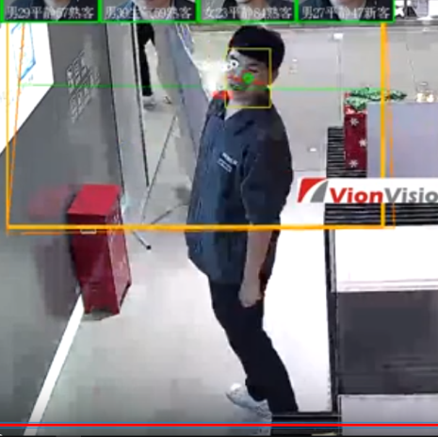

**Phase -5** Compare the Embeddings and calculating the Euclidean Distance. If the result is a low value, then the time duration will be calculated.

* 1. **Libraries, Classifiers and Platform**

|  |  |
| --- | --- |
| Platform | Ubuntu,Wndows |
| Language | Python |
| Technology | Anaconda 3.6 |
| Libraries and Packages | Dlib ,OpenCV ,Tensorflow ,Numpy, face_recognition ,pickle |

* 1. **Project Development Time Schedule  
       
     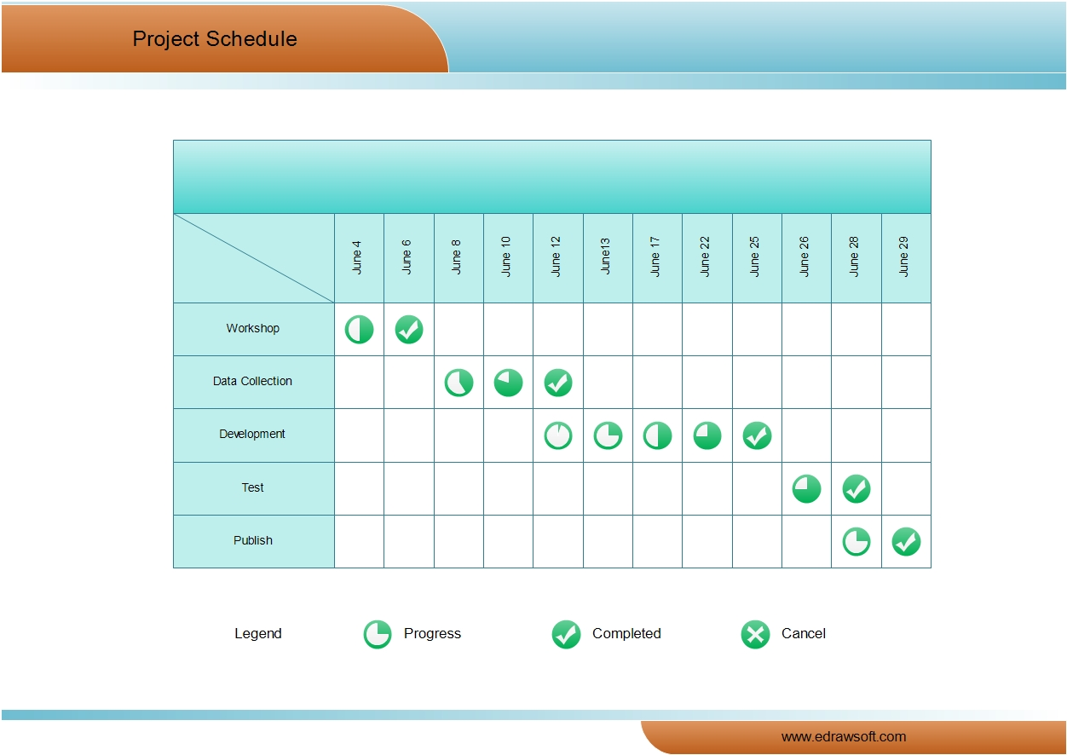**
  2. **Project Screenshots**

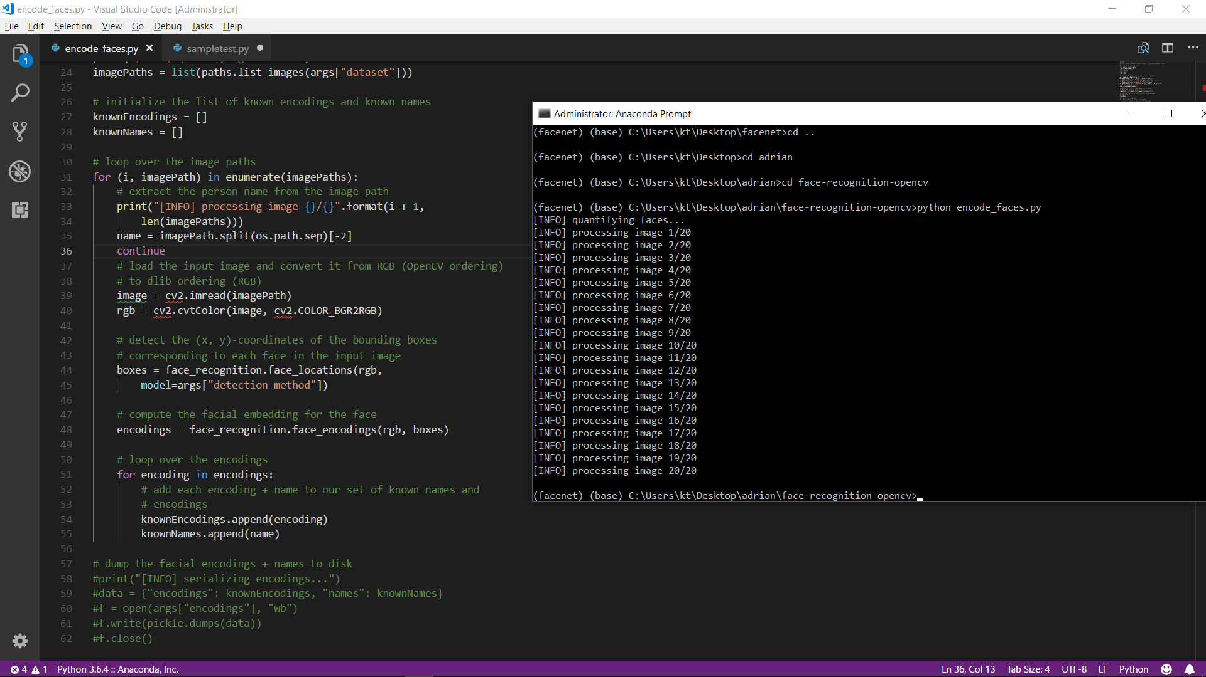Training Process

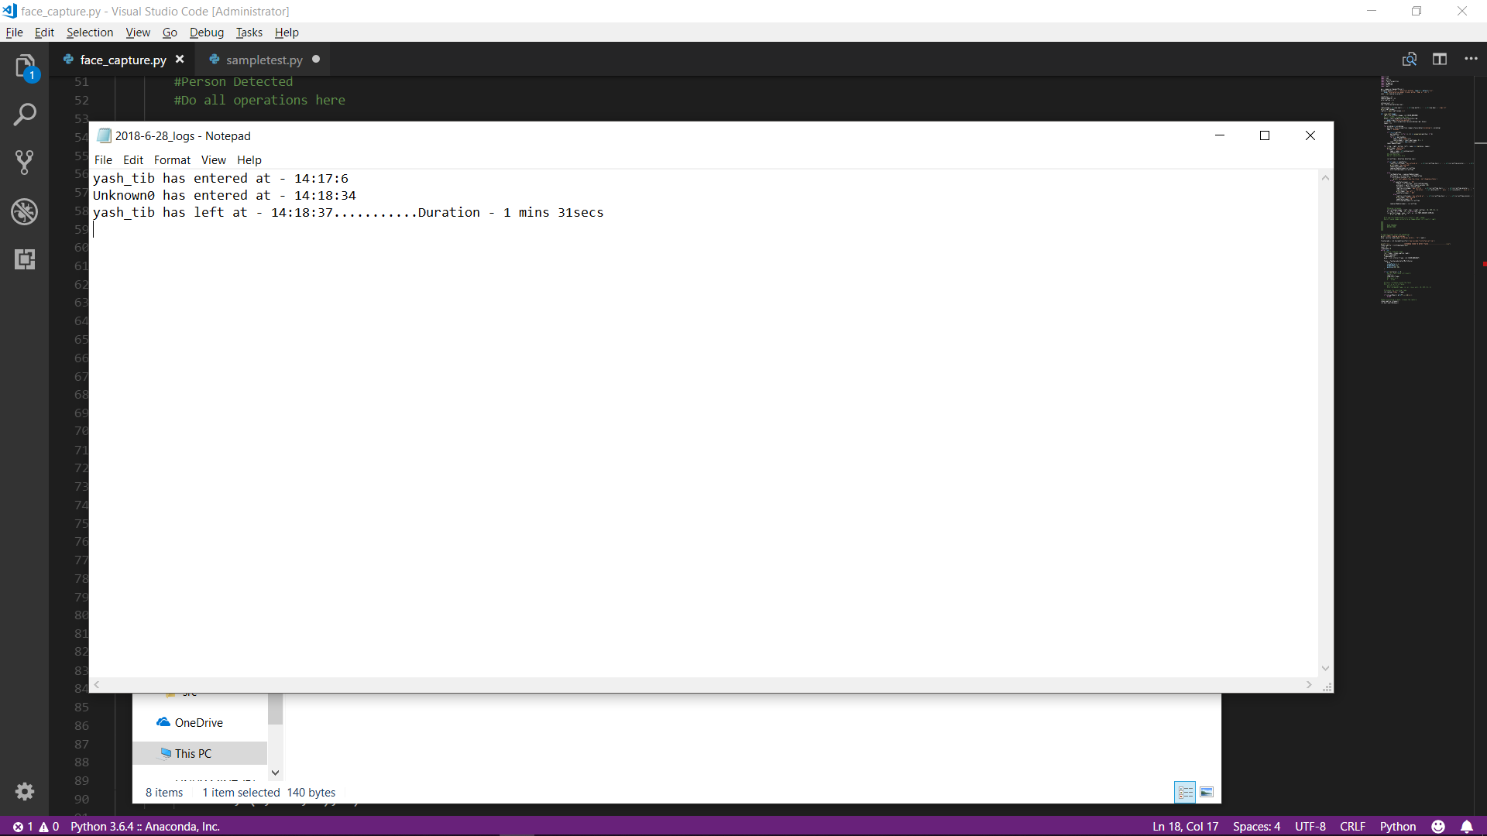

Log File OUTPUT

FACE DETECTION SCREENSHOTS

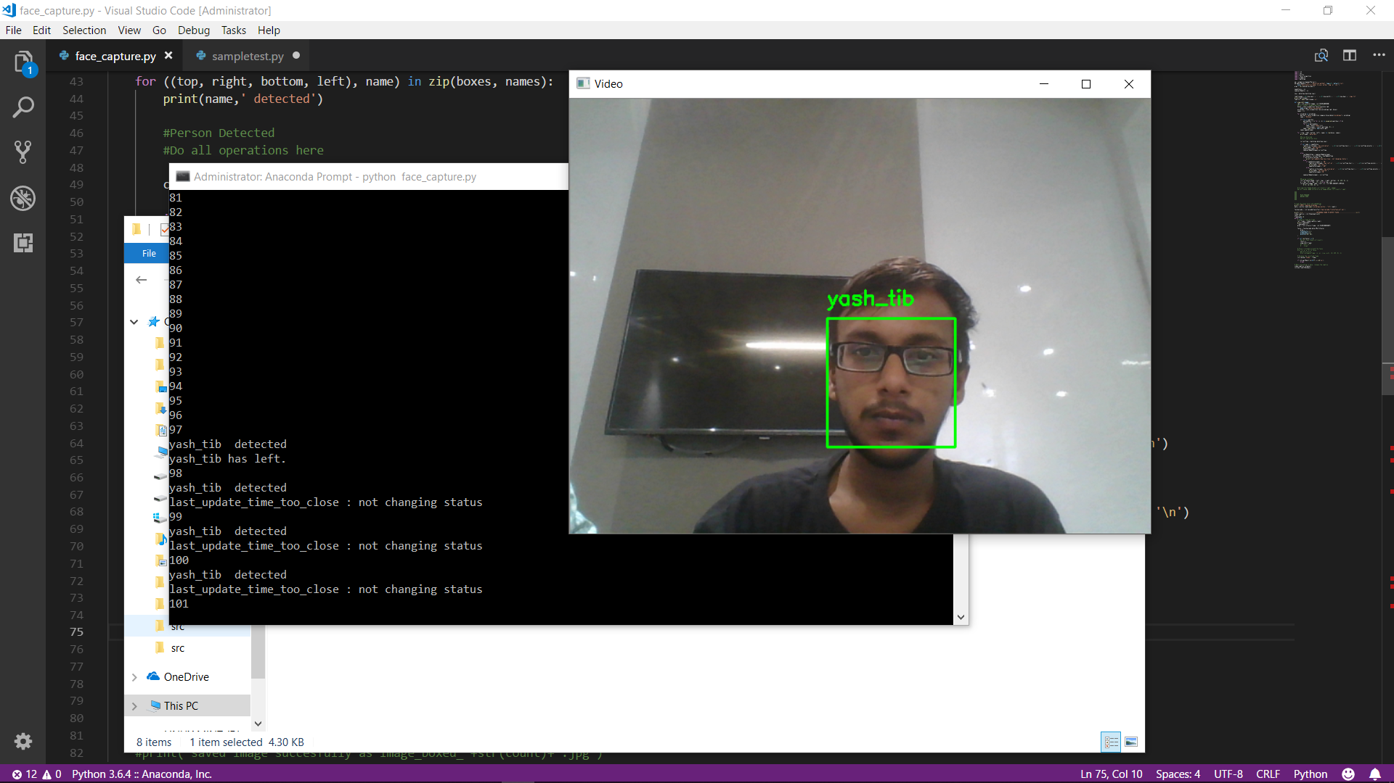

LEAVING

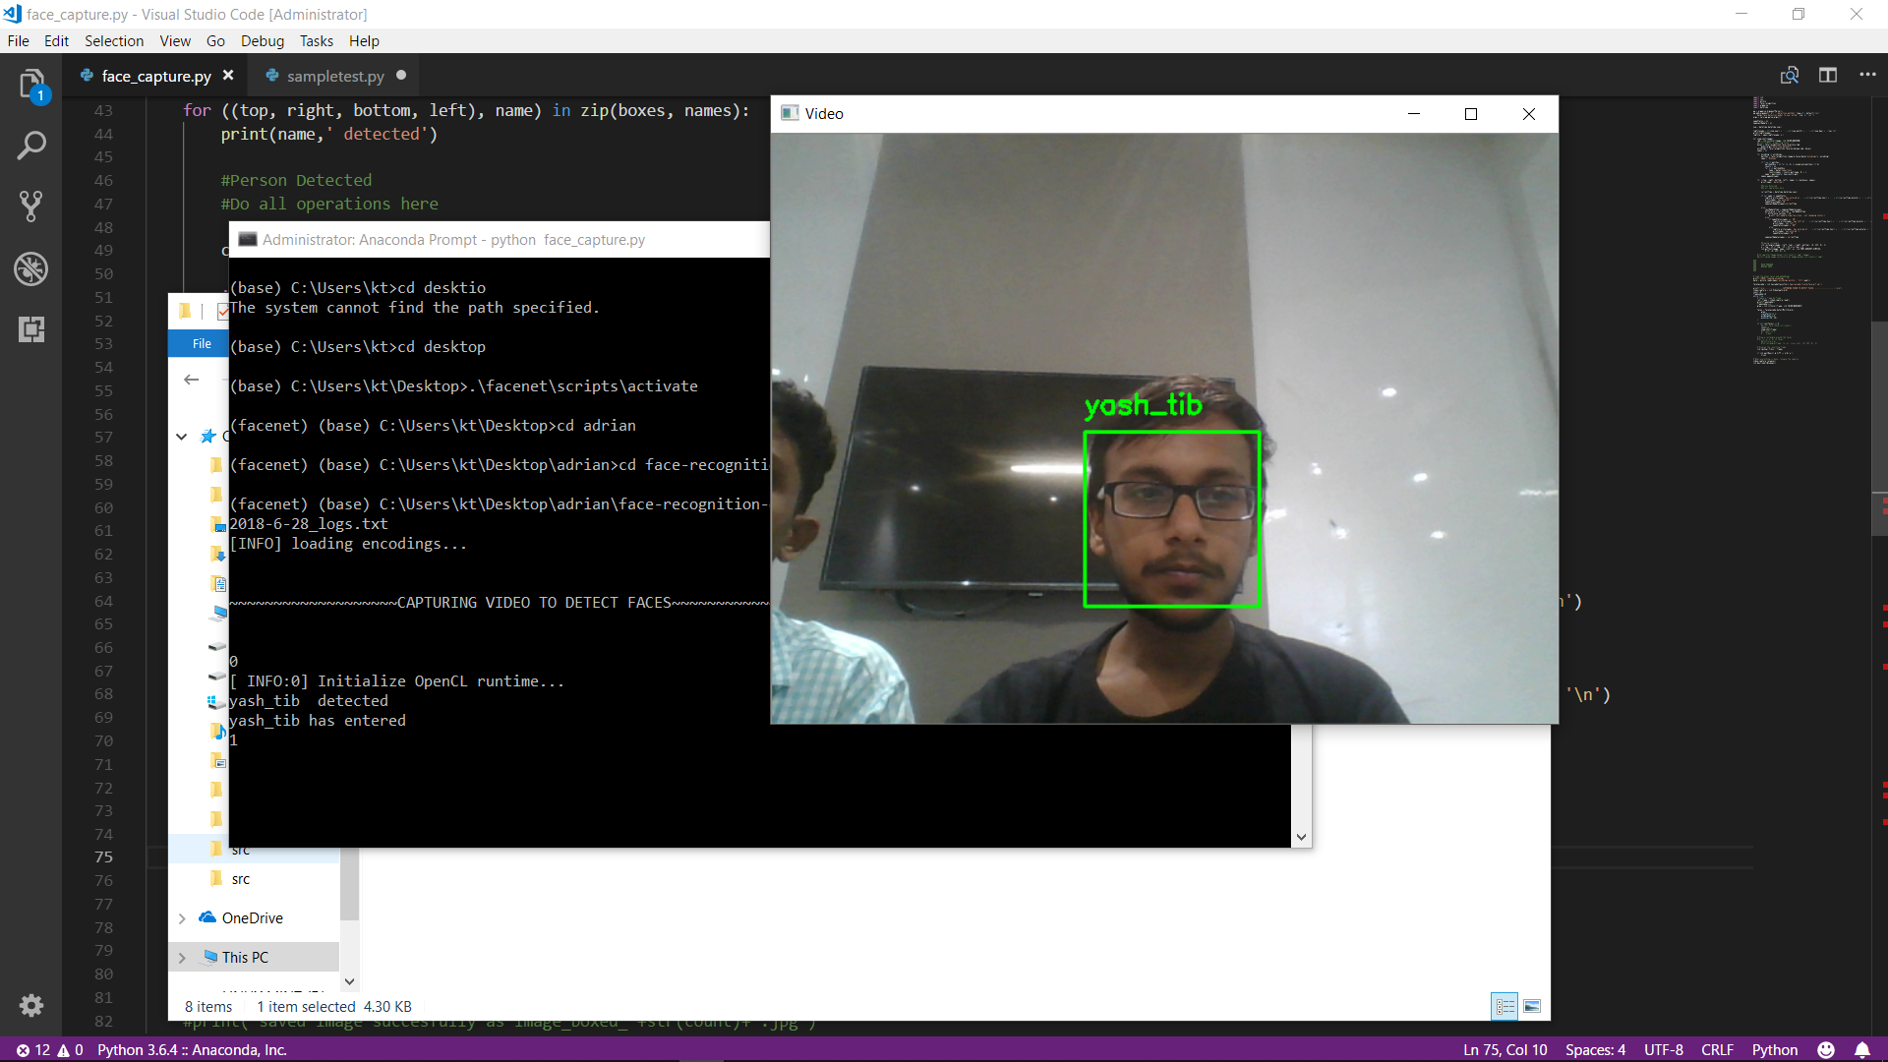

ENTERING

**3.1 Conclusion**

Face recognition can be applied in Security measure at Banks, Offices, Homes etc.. Face recognition has received substantial attention from researches in biometrics, pattern recognition field and computer vision communities. Here Face Recognition along with real time Tracking offers wide range of applications like Automated Attendance System, Automated Billing based on time of consumption, Automated Visitor Tracking, Tracking unauthorized persons etc.

**3.2 Limitations**

The proposed systems have the following limitations:

* Image quality affects how well facial-recognition algorithms work. The image quality of scanning video is quite low compared with that of a digital camera
* The relative angle of the target’s face influences the recognition score profoundly.
* Multithreading can be implemented to make the software more efficient and increase frame rate.

**3.3 Future Scope**

By the application of similar Real Time Face recognition and Tracking system in future the case of anonymity can be avoided. Nobody can remain as an anonymous person; everybody will be monitored and traceable. In future the Range of surveillance can be extended to more area. So that more security can be offered. The Scope of the project can be extended by implementing it on Raspberry Pi and by using micro cameras. This Project can also be extended by using it for the automated Attendance System Using Face Recognition And Tracking.

**Links**

**References**

1. https://blog.paperspace.com/facial-recognition-using-deep-learning/
2. https://disruptionhub.com/5-applications-facial-recognition-technology/
3. https://money.cnn.com/2012/01/13/technology/face_recognition/index.htm
4. <https://blog.algorithmia.com/understanding-facial-recognition-openface/>
5. https://medium.com/@vinayakvarrier/building-a-real-time-face-recognition-system-using-pre-trained-facenet-model-f1a277a06947

CERTIFICATE

**PROJECT MEMBERS GROUP NO -19**

Yash Tibarewala ………………………………………..

Thapar Institute of Engineering and Technology

Patiala

Jithu Divakaran ...............................................

Saintgits College of Engineering,

Kerala, Kottayam

**Mentor Internship Coordinator:**

Mr. Tejalal Choudhary **Dr. Madhushi Verma**

Ph.D. Scholar Assistant Professor

Bennett UniversityBennett University

………………………………  **……………………………………..**

**CERTIFICATE**

***Certified that this is the bonafide record of the project work***

***as a part of Summer Internship***

***Entitled***

**Image Classification**



**Submitted by,**

**Rohith CA ………………………………………..**

**Mentor: Internship Coordinator:**

**Mr. Suneet Gupta Dr. Madhushi Verma**

**……………………………………. …………………………………….**